AUTOMATION AND ROBOTICS

MATLAB LABORATORY EXERCISE

AIM:

To learn the basic operation of MATLAB simulation software and see how basic control systems can be implemented.

OBJECTIVES:

- Learn how to to perform basic data entry in MATLAB
- Understand how to use basic operators in MATLAB
- Undestand how to manipulate matricies in MATLAB
- Learn how to plot graphs in MATLAB
- Learn how to represent polynomials in MATLAB
- Learn how to analyse first and second order control systems in MATLAB
- Learn how to use Simulink
- Learn ho to analyse systems with PID control in Simulink

LABORATORY INFORMATION:

Login to the student account. The password is 152.

Use a USB memory stick to save results you are likely to encounter problems if you try to use cloud storage.

Introduction
MATLAB is an interactive program for numerical computation and data visualization; it is used extensively by control engineers for analysis and design. There are many different toolboxes available which extend the basic functions of MATLAB into different application areas. MATLAB is supported on Unix, Macintosh, and Windows environments; a student version of MATLAB is available for personal computers. For more information on MATLAB, please visit the MathWorks home page.

The idea behind these tutorials is that you can view them in one window while running MATLAB in another window. You should be able to re-do all of the plots and calculations in the tutorials by cutting and pasting text from the tutorials into the MATLAB Command Window or an m-file.

Getting Started
These notes assume that the reader uses Windows and has no programming experience. Linux / Unix users and people with experience of C - please be patient.

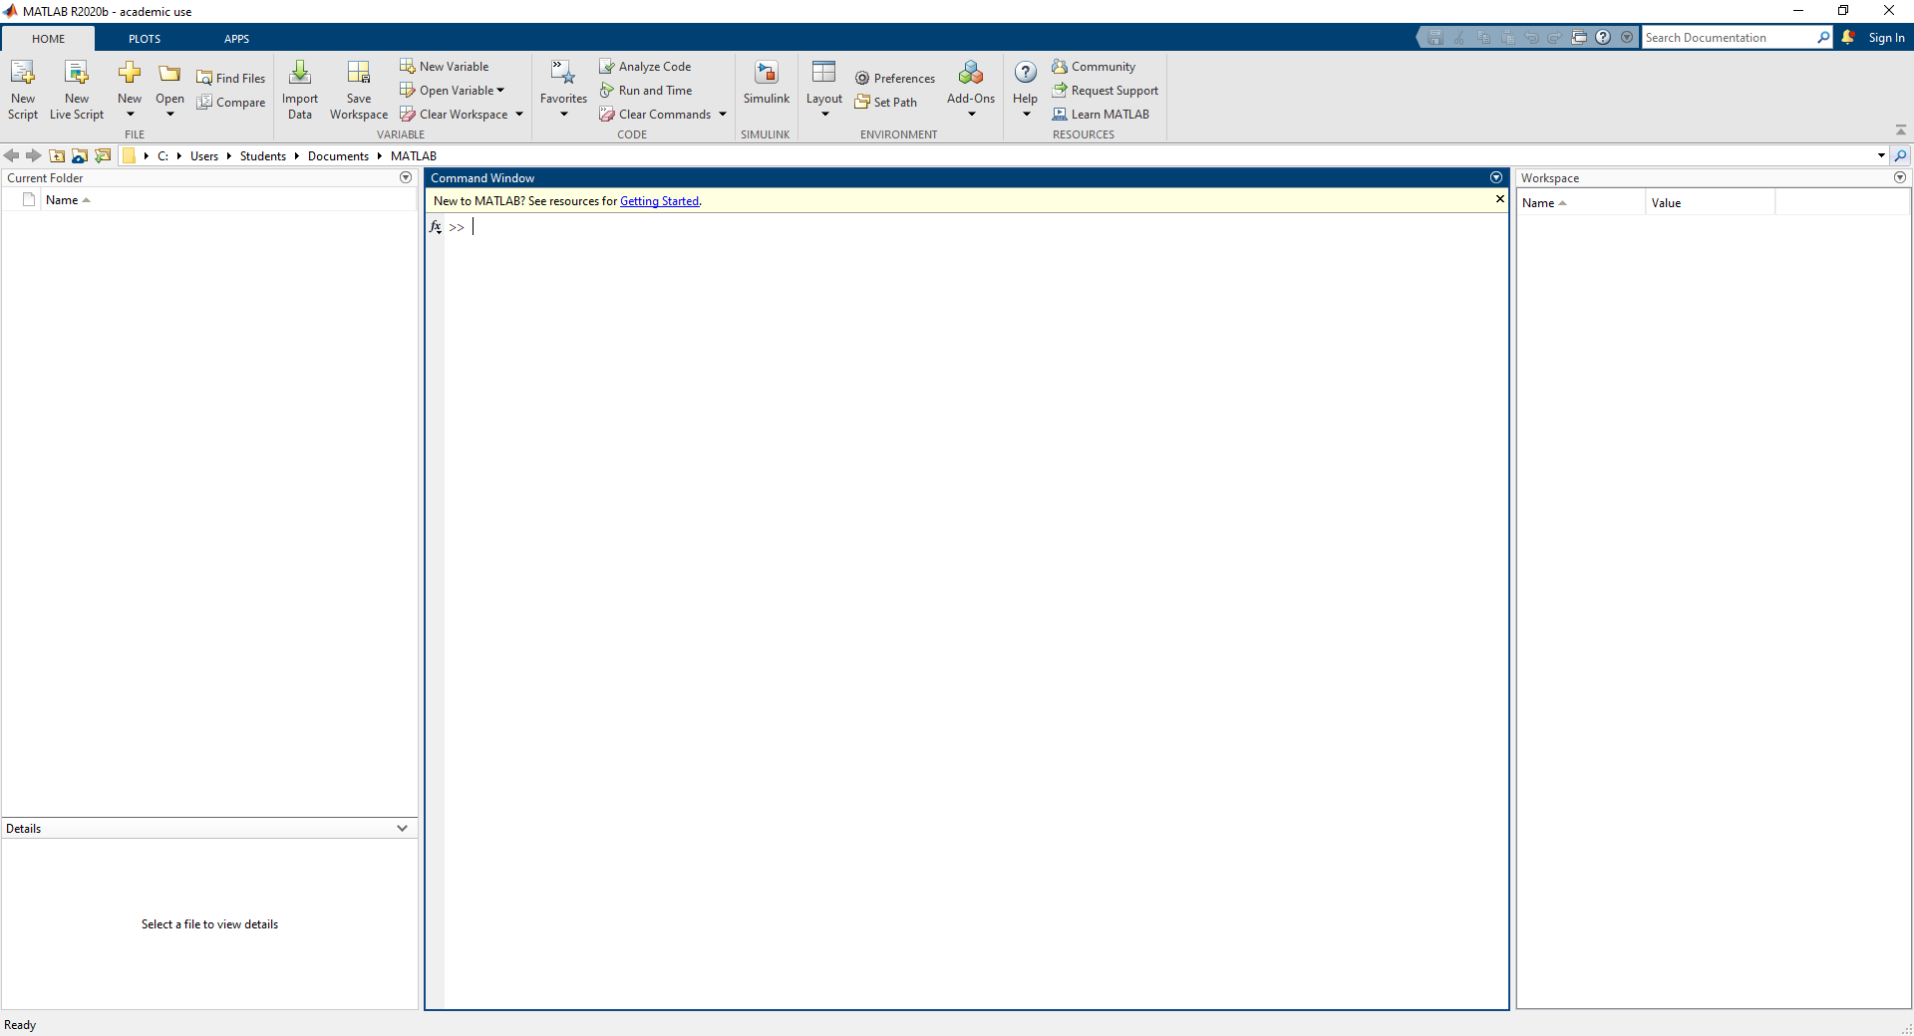
Start MATLAB by clicking on the icon on your desktop, and a variety of windows will open up.

The main blank window is the command window, which has a prompt >> where you type your instructions to MATLAB.
The current directory is shown at the top of the command window, and you can change directories by using the directory ribbon. You can also use the system commands ls, cd, dir and pwd to move between directories.
As you read though this tutorial, try typing each line into MATLAB, and if you don't understand what it is doing, try something else until you do. The only way to learn MATLAB is by using it, so just try stuff. Though out this tutorial, things you type into MATLAB are show in green and MATLAB's response is shown in blue. Words highlighted in red are (in general) defined in the glossary at the end.

Getting help
MATLAB has a detailed help section, which you can access by clicking on the question mark at the top of the command window and searching. At any time, you can type help to get a list of categories of commands, for example type help general for a list of general commands. Type help followed by a command name to get more help on that command. For example:
>> help length
LENGTH Length of vector.
LENGTH(X) returns the length of vector X.
It is equivalent to MAX(SIZE(X)) for non-empty arrays and 0 for empty ones

The Basics
MATLAB is based on a command line where you can see and manipulate variables. You enter commands at the prompt >> and MATLAB responds.
To create the variable A with the value 10 (N.B. spaces before and after = are optional).
>> A=10
A =10
A is now stored as a variable in MATLAB's memory or workspace with the value 10. It can be used in sums etc
>> A+A
ans = 20
You can also put the result of a sum straight into a variable
>> B=5+8
B= 13
If you put a semi-colon at the end of the line, MATLAB won’t show you the output of that command, but the value of the variable has still been changed.
>> A = 15;

Now type the name of the variable to see its new value:
>> A
A = 15
The name of a variable must begin with a letter, but can have numbers later in the name. Names are case-sensitive, and can be up to 32 characters long, but cannot have spaces or punctuation in the name. You can use underscore _ if you want a space, and there are certain reserved words like if which cannot be used as variable names. If you use a command name as a variable name, that command may not work and you will have to clear your variable to use the command
To get rid of a variable, type clear followed by the name:
>> clear B
You can clear everything in the workspace by typing clear all
The command whos shows you the variables that are in the workspace. You will see:
Name: the name you use to refer to the variable
Size: the number of rows (first number) and columns (second number)
Bytes: how much memory the variable uses, but you don’t need to know that unless you are using very big variables.
Type: all numbers are double arrays, but you can also use text, cell and logical.
>> whos
Name | Size | Bytes | Class
A | 1x1 | 8 | double array
ans | 1x1 | 8 | double array

You can clear the variables you have created with the command clear. Use clear var to remove just the variable var or use clear all to clear everything
>> clear all

Basic Functions
MATLAB has a large number of build in functions which allow you to perform simple maths. Functions are bits of code (written by you or MATLAB or anyone) which receive some inputs and give you some outputs. They use round brackets, and all functions written by MATLAB have help files to tell you how to use them. Type help followed by the command name for details.
All functions have one or more inputs or arguments and produce one or more outputs. If a function has just one output, the output can be placed straight into a variable, but if a function has several outputs, square brackets are needed to group the output variables.
All functions have the form:
[output1, output2, ...] = function (arg1, arg2, ...)
All the mathematical functions you need to operate on single values are available, e.g sin, cos, tan, sqrt, log and pi.

Matrices and Punctuation
If you are familiar with Excel, you will be used to the idea of putting all your data into a grid, and then adding up the rows or columns to do your analysis. MATLAB lets you have as many grids or arrays as you like, of any size, and each one is a variable with a name. You can then use the variable name to refer to the array when you want to manipulate it. Some types of array are:
Scalar – a single number
A = 10
Vector – a row or column of numbers
B = 1 2 3
C = 4
3
8
Matrix – an array of numbers in a grid, its size is the number of rows x the number of columns. D is a 3 by 4 matrix.

D = 5 | 6 | 7 | 9
8 | 3 | 5 | 3
5 | 6 | 3 | 2
Element – a single number within a matrix or vector.

Brackets
To enter most data into MATLAB, you need to use square brackets [ ]
To put data into a row vector, type the values within square brackets, separated by spaces OR commas (or both).
>> C = [6, 5, 8, 10]
C = 6 5 8 10

To put data into a column vector, type the values in square brackets, separated by semi colons. In this context, semi-colon means 'start a new line'.
>> D = [3; 1; 6; 5]
D = 3
1
6
5

To put data into a matrix, use commas for the rows and then a semi-colon to start each new line. It is just like doing a row and column vector at once.
>> E = [1, 2, 3; 4, 5, 6]
E = 1 2 3
4 5 6
In general, square brackets are used any time that you want to join things together. See vertcat and horzcat for more information.
Use round brackets ( ) to get things out of a matrix or to refer to just part of a matrix. For example, E(2,3) means the value in row 2, column 3 of E
>> E(2,3)
ans = 6
If you try to refer to something outside E, you will get an error message
>> E(4,3)
Index exceeds matrix dimensions.
You can also use round brackets to change part of a matrix. To make the number in the 1st row and 3rd column of E be 10, type
>> E(1,3) = 10

E = | 1 | 2 | 10
 | 4 | 5 | 6
and if you want to add a row or column to a matrix, you just need to refer to it and it will be created. Note that this only works if you are adding a row or column of the same size as your original matrix, if you try adding a different size, you will get an error message.
>> E(3,:) = [7, 8, 9]

E = | 1 | 2 | 10
 | 4 | 5 | 6
 | 7 | 8 | 9

Colon
The colon character : means several different things in MATLAB. In round brackets, a colon means everything in a row or column and is normally used to extract data from a matrix.
E(:,2) means everything in column 2 of E. Read this as 'E, every row, column 2'
>> E(:,2)
ans = 2
5
8

E(2,:) means every column in row 2 of E. Read this as 'E, row 2, every column'
>> E(2,:)
ans = 4 5 6
A colon in brackets by itself turns anything into a column vector. E(:) rearranges everything in E into one long column
>> E(:)
ans = 1
4
7
2
5
8
10
6
9
Between two numbers, the colon means count from A to B one integer at a time
>> F = 5:10
F = 5 6 7 8 9 10
You can use a colon like this to extract data from a matrix too. For example, F(:,3:5) means everything in columns 3, 4 and 5 of F
>> F(:,3:5)
ans = 7 8 9

A set of three numbers with a colon specifies the step to use for counting, e.g. G = 3:4:20 means G counts from 3 to 20 in steps of 4
>> G = 3:4:20
ans = 3 7 11 15 19
Type help punct, help colon and help paren for more information on matrix punctuation in MATLAB.

The Array Editor
Use the menus to select Window - Workspace and MATLAB will show you a window listing all your variables and their sizes, similar to typing whos. If you then click on a variable, the Array Editor window opens. This shows you the data in a grid a bit like Excel, and any numbers you change here will be changed in MATLAB's memory, while commands at the command prompt which change the variable you are looking at will automatically be shown in the array editor. You can also paste data from another program (like Excel) into a MATLAB variable.

Indexing
Indexing means getting the part of a matrix you want, and it is crucial to MATLAB. The easiest way to get the data you want is to use subscripts, i.e. to tell MATLAB the rows and columns that you want.
For this example, we will use a magic square matrix which is stored in MATLAB and accessed with the command magic.
>> clear all
>> A = magic(5)

A = 17 | 24 | 1 | 8 | 15
23 | 5 | 7 | 14 | 16
4 | 6 | 13 | 20 | 22
10 | 12 | 19 | 21 | 3
11 | 18 | 25 | 2 | 9
We can extract the value in row 4 column 3 from A, using round brackets
>> B = A(4,3)
B = 19
or just row 4, read this as C is A, row 4 all columns
>> C = A(4,:)
C = 10 12 19 21 3
We can extract rows 2 and 3 from A. Read this as D is A, rows 2 and 3, all columns. The square brackets and semi-colon are used to join the required rows together and the round brackets to extract the rows from A.
>> D = A([2;3],:)

D = 23 | 5 | 7 | 14 | 16
4 | 6 | 13 | 20 | 22
And we can extract columns 1 to 3 of D. Read this as E is D, all rows from columns 1 through 3
>> E = D(:,1:3)
E = 23 5 7
4 6 13

We can also use indexing to put values into A, e.g. to make row 2 column 2 of A equal 100, use:
>> A(2,2) = 100

A = 17 | 24 | 1 | 8 | 15
23 | 100 | 7 | 14 | 16
4 | 6 | 13 | 20 | 22
10 | 12 | 19 | 21 | 3
11 | 18 | 25 | 2 | 9

To make all of column 4 of A equal 0, use
>> A(:,4) = 0

A = 17 | 24 | 1 | 0 | 15
23 | 100 | 7 | 0 | 16
4 | 6 | 13 | 0 | 22
10 | 12 | 19 | 0 | 3
11 | 18 | 25 | 0 | 9

Basic Maths
Type clear all before starting this section, and enter E = [1, 2, 3; 4, 5, 6] and A=10.
In MATLAB, you can do sums on numbers or on variables. Variables are treated just like the number (or numbers) they represent. Most things are as you would expect:
+ means plus
- means minus
' means transpose (turn rows into columns and vice versa)
( ) round brackets can be used to specify the order of operations according to BODMAS

BUT
* means matrix multiplication
/ means matrix division
You are more likely to want to dot-multiple and dot-divide
.* means element-wise multiplication
./ means element-wise division
.^ means power (i.e. A.^2 means A squared)
You can do calculations on single numbers just by typing in the command line. Spaces before and after the signs are optional.
>> 174 .* 734
ans = 127716
>> (A*2) / 5
ans = 4
You can also do calculations between a scalar and a matrix. The calculation will be applied to every value of the matrix.
>> J = E*A

J = | 10 | 20 | 30
 | 40 | 50 | 60

You can add and subtract matrices if they are the same size:
>> K = J – E

ans = | 9 | 18 | 27
 | 36 | 45 | 54

You can multiple or divide elements of two matrices using .* and ./ The matrices must both be of the same size, otherwise you will get an error message.
>> L = [3 2 1; 9 5 6]

L = | 3 | 2 | 1
 | 9 | 5 | 6
To divide each value of K by the value in the equivalent place from L:
>> K./L

ans = 3 | 9 | 27
4 | 9 | 9

To multiply each value of E by the value in the equivalent place from L:
>> E.*L
ans =

3 | 4 | 3
36 | 25 | 36
Note that using * and / without the . will perform matrix multiplication and division, where whole rows and columns are multiplied and summed. This is described in linear algebra text books, but you are unlikely to need it for basic data analysis. If you multiply and you get back a matrix of a different shape, you’ve probably done matrix multiplication. If your matrix is square (has the same number of rows and columns), be extra careful because matrix multiplication won't produce an obvious error.
Type help elfun (elementary functions) help ops (operators) or help arith (arithmetic) for more information on basic maths with MATLAB.

Matrix Functions
MATLAB has a variety of useful functions which you can apply to the rows or columns of a matrix, including sum, mean, std, max and min.
By default, these work on columns, but you can change the dimension to work on rows. Type help followed by the function name to see how to do this.
To sum the columns of K:
>> sum(K)
ans = 45 63 81

To sum the rows of K, you must tell the sum function to operate in the 2nd dimension (1st = columns, 2nd = rows)
>> sum(K,2)
ans = 54
135
To find the mean of J and put it in a variable
>> mj = mean(J)
mj = 25 35 45

The apostrophe is useful to transpose a matrix or vector, i.e. to turn all the rows into columns and the columns into rows
>> K'

ans = | 9 | 36
 | 18 | 45
 | 27 | 54
There are also a set of functions to create vectors and matrices. These include rand, ones, zeros, repmat, ndgrid, linspace, logspace and magic.
e.g. To create a matrix of random numbers with 3 rows and 5 columns (yours will be different because R is random)
>> R = rand(3,5)
R =
0.6154 | 0.7382 | 0.9355 | 0.8936 | 0.8132
0.7919 | 0.1763 | 0.9169 | 0.0579 | 0.0099
0.9218 | 0.4057 | 0.4103 | 0.3529 | 0.1389
Many more useful functions are listed in the glossary. type help followed by a function name to find out what each one does.

Logical Operators
Type clear all before starting this section to clear all the previous variables.
Logical operators are used to assess if a statement is true or false. False is always represented by 0, and MATLAB will consider any non-zero value to be true. For neatness, it is best to use 1 as true. Logicals can be used to decide which part of a script to run next or which elements of a matrix to use in a calculation. There are four main logical operators:
> Greater than
< Less than
== Is equal to
~= Is not equal to
You can also join logicals together using AND, OR and NOT, together with round brackets
& logical AND
| logical OR
~ logical NOT
In MATLAB, you can apply logical operators to whole arrays as well as to individual numbers, and then you obtain a logical array which can be used to index another array.

In this example, B shows which values of A are larger than 2, and C shows which values of A are smaller than 5.
>> A = [1 5 3 4 8 3];
>> B = A>2
B = 0 1 1 1 1 1
>> C = A<5
C = 1 0 1 1 0 1
D shows where both B and C are true.
>> D = B & C
D = 0 0 1 1 0 1
You can see that B, C and D are a logical when you type whos and the class is listed as logical. This means MATLAB will treat these matrices as a list of True and False values rather than just a list of ones and zeroes.
Now you can use D as a logical index into A:
>>E = A(D)
E = 3 4 3

E contains only the values of A which are true according to D, that is, only the values which are larger than 2 AND smaller than 5. For these values, there was a one (TRUE) in the corresponding place in D, and all the other values in A are dropped.
Logical indices can often be used in a similar to the subscript indices described above. Both function to select out particular values from an array. You can convert a logical index into a subscript index using find, which tells you the non-zeros values of the logical.
>> F = find(D)
F = 3 4 6
This means that the 3rd, 4th and 6th values of D are not zero. If you use the subscript index F into A, you will get the same result as using the logical index D into A:
>> A(F)
ans = 3 4 3
Logical indexing is most useful when one variable is used to categorise another. Imagine you have some data which falls into three different categories.
>> data = [4 14 6 11 3 14 8 17 17 12 10 18];
>> cat = [1 3 2 1 2 2 3 1 3 2 3 1];
To find where cat is 2:
>> cat2 = cat==2
cat2 = 0 0 1 0 1 1 0 0 0 1 0 0
To find the values of data where cat is 2:
>> data2 = data(cat2);
data2 = 6 3 14 12
Now we can find the mean of the data for category 2
>> mdat2 = mean(data2)
mdat2 = 8.75
We could have done all 3 steps in one line:
>> mdat2 = mean(data(cat==2))
mdat2 = 8.75

Plotting

It is also easy to create plots in MATLAB. Suppose you wanted to plot a sine wave as a function of time. First, make a time vector (the semicolon after each statement tells MATLAB we don't want to see all the values) and then compute the sin value at each time. The commands after the plot function (title, xlabel, ylabel) will add annotations to the plot.

t= 0:0.25:7;
y = sin(t);

plot(t,y)
title('Sine Wave as a Function of Time')
xlabel('Time (secs)')
ylabel('Amplitude')

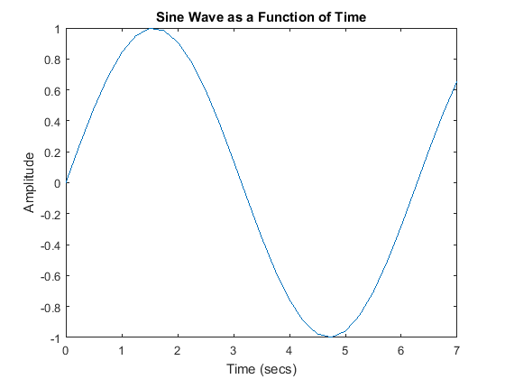
The plot contains approximately one period of a sine wave. Basic plotting is very easy in MATLAB, and the plot command has extensive add-on capabilities. You may visit the plotting page to learn more.

Polynomials as Vectors
In MATLAB, a polynomial is represented by a vector. To create a polynomial in MATLAB, simply enter each coefficient of the polynomial into the vector in descending order. For instance, let's say you have the following polynomial:

To enter this into MATLAB, just enter it as a vector in the following manner:
x = [1 3 -15 -2 9]
x = 1 3 -15 -2 9
MATLAB can interpret a vector of length n+1 as an nth order polynomial. Thus, if your polynomial is missing any coefficients, you must enter zeros in the appropriate place in the vector. For example,

would be represented in MATLAB as:
y = [1 0 0 0 1]
y = 1 0 0 0 1
You can find the value of a polynomial using the polyval function. For example, to find the value of the above polynomial at s = 2,

z = polyval([1 0 0 0 1],2)
z =17
You can also extract the roots of a polynomial. This is useful when you have a high-order polynomial such as

Finding the roots would be as easy as entering the following command:
roots([1 3 -15 -2 9])
ans =
-5.5745
2.5836
-0.7951
0.7860
Let's say you want to multiply two polynomials together. The product of two polynomials is found by taking the convolution of their coefficients. MATLAB's function conv will do this for you.

x = [1 2];
y = [1 4 8];
z = conv(x,y)
z = 1 6 16 16
Dividing two polynomials is just as easy. The deconv function will return the remainder as well as the result. Let's divide z by y and see if we get x.
[xx, R] = deconv(z,y)
xx = 1 2
R = 0 0 0 0
As you can see, this is just the polynomial/vector x from before. If y had not gone into z evenly, the remainder vector would have been something other than zero.

Polynomials Using the s Variable
Another way to represent a polynomial is to use the Laplace variable s within MATLAB. This method is mainly used throughout these tutorials. Let's ignore the details of the Laplace domain for now and just represent polynomials with the s variable. To define the variable, type the following into the MATLAB command window:

s = tf('s')
s = s
Recall the polynomial given above:

To represent this in MATLAB, type the following into the MATLAB command window:
polynomial = s^4 + 3*s^3 - 15*s^2 - 2*s + 9
polynomial = s^4 + 3 s^3 - 15 s^2 - 2 s + 9
Instead of using the roots function, we can use the zero function to find the roots of the polynomial.

zero(polynomial)
ans =
-5.5745
2.5836
-0.7951
0.7860
As you can see, the result is the same as above using the roots command and the coefficients of the polynomial.
You can also multiply two polynomials together using the s variable. Let's redefine x and y.

x = s + 2;
y = s^2 + 4*s + 8;
z = x * y
z = s^3 + 6 s^2 + 16 s + 16
The resulting polynomial has the same coefficients as the resulting vector from the conv function above.

System Analysis
Once appropriate mathematical models of a system have been obtained, either in state-space or transfer function form, we may then analyse these models to predict how the system will respond in both the time and frequency domains. To put this in context, control systems are often designed to improve stability, speed of response, steady-state error, or prevent oscillations. In this section, we will show how to determine these dynamic properties from the system models.

Time Response Overview
The time response represents how the state of a dynamic system changes in time when subjected to a particular input. Since the models we have derived consist of differential equations, some integration must be performed in order to determine the time response of the system. For some simple systems, a closed-form analytical solution may be available. However, for most systems, especially nonlinear systems or those subject to complicated inputs, this integration must be carried out numerically.

Fortunately, MATLAB provides many useful resources for calculating time responses for many types of inputs, as we shall see in the following sections.

The time response of a linear dynamic system consists of the sum of the transient response which depends on the initial conditions and the steady-state response which depends on the system input. These correspond to the homogenous (free or zero input) and the particular solutions of the governing differential equations, respectively.

Frequency Response Overview
All the examples presented are modeled by linear constant coefficient differential equations and are thus linear time-invariant (LTI). LTI systems have the extremely important property that if the input to the system is sinusoidal, then the steady-state output will also be sinusoidal at the same frequency, but, in general, with different magnitude and phase. These magnitude and phase differences are a function of the frequency and comprise the frequency response of the system.

The frequency response of a system can be found from its transfer function in the following way: create a vector of frequencies (varying between zero or "DC" to infinity) and compute the value of the plant transfer function at those frequencies. If is the open-loop transfer function of a system and is the frequency vector, we then plot versus . Since is a complex number, we can plot both its magnitude and phase (the Bode Plot) or its position in the complex plane (the Nyquist Diagram). Both methods display the same information, but in different ways.

Stability
For our purposes, we will use the Bounded Input Bounded Output (BIBO) definition of stability which states that a system is stable if the output remains bounded for all bounded (finite) inputs. Practically, this means that the system will not "blow up" while in operation.

The transfer function representation is especially useful when analyzing system stability. If all poles of the transfer function (values of for which the denominator equals zero) have negative real parts, then the system is stable. If any pole has a positive real part, then the system is unstable. If we view the poles on the complex s-plane, then all poles must be in the left-half plane (LHP) to ensure stability. If any pair of poles is on the imaginary axis, then the system is marginally stable and the system will tend to oscillate. A system with purely imaginary poles is not considered BIBO stable. For such a system, there will exist finite inputs that lead to an unbounded response. The poles of an LTI system model can easily be found in MATLAB using the pole command, an example of which is shown below:

s = tf('s');
G = 1/(s^2+2*s+5)
pole(G)
G =
1
-------------
s^2 + 2 s + 5
ans =
-1.0000 + 2.0000i
-1.0000 - 2.0000i
Thus this system is stable since the real parts of the poles are both negative. The stability of a system may also be found from the state-space representation. In fact, the poles of the transfer function are the eigenvalues of the system matrix . We can use the eig command to calculate the eigenvalues using either the LTI system model directly, eig(G), or the system matrix as shown below.

[A,B,C,D] = ssdata(G);
eig(A)
ans =
-1.0000 + 2.0000i
-1.0000 - 2.0000i

System Order
The order of a dynamic system is the order of the highest derivative of its governing differential equation. Equivalently, it is the highest power of in the denominator of its transfer function. The important properties of first-, second-, and higher-order systems will be reviewed in this section.

First-Order Systems
First-order systems are the simplest dynamic systems to analyze. Some common examples include mass-damper systems and RC circuits.
The general form of the first-order differential equation is as follows
(1)
The form of a first-order transfer function is
(2)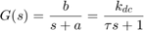
where the parameters and completely define the character of the first-order system.
DC Gain

The DC gain, , is the ratio of the magnitude of the steady-state step response to the magnitude of the step input. For stable transfer functions, the Final Value Theorem demonstrates that the DC gain is the value of the transfer function evaluated at = 0. For first-order systems of the forms shown, the DC gain is .

Time Constant

The time constant of a first-order system is which is equal to the time it takes for the system's response to reach 63% of its steady-state value for a step input (from zero initial conditions) or to decrease to 37% of the initial value for a system's free response. More generally, it represents the time scale for which the dynamics of the system are significant.
Poles/Zeros

First-order systems have a single real pole, in this case at . Therefore, the system is stable if is positive and unstable if is negative. Standard first-order system have no zeros.
Step Response

We can calculate the system time response to a step input of magnitude using the following MATLAB commands:
k_dc = 5;
Tc = 10;
u = 2;
s = tf('s');

G = k_dc/(Tc*s+1)
step(u*G)
G =
5
--------
10 s + 1
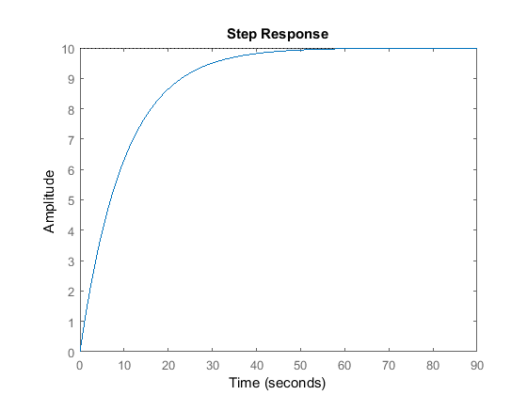
Note: MATLAB also provides a powerful graphical user interface for analyzing LTI systems which can be accessed using the syntax linearSystemAnalyzer('step',G).

If you right-click on the step response graph and select Characteristics, you can choose to have several system metrics overlaid on the response: peak response, settling time, rise time, and steady-state.

Settling Time

The settling time, , is the time required for the system output to fall within a certain percentage (i.e. 2%) of the steady-state value for a step input. The settling times for a first-order system for the most common tolerances are provided in the table below. Note that the tighter the tolerance, the longer the system response takes to settle to within this band, as expected.
10% | 5% | 2% | 1%
Ts=2.3/a=2.3Tc | Ts=3/a=3Tc | Ts=3.9/a=3.9Tc | Ts=4.6/a=4.6Tc
Rise Time

The rise time, , is the time required for the system output to rise from some lower level x% to some higher level y% of the final steady-state value. For first-order systems, the typical range is 10% - 90%.
Bode Plots

Bode diagrams show the magnitude and phase of a system's frequency response, , plotted with respect to frequency . We can generate the Bode plot of a system in MATLAB using the syntax bode(G) as shown below.

bode(G)
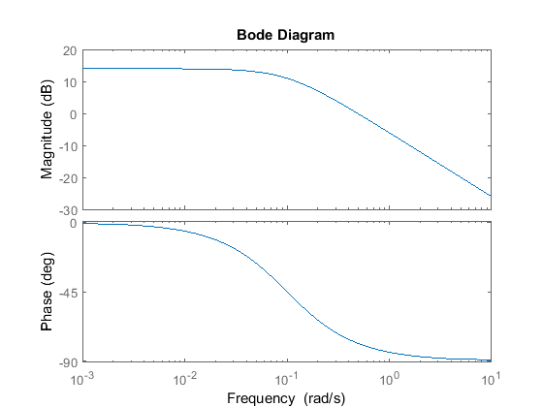
Again the same results could be obtained using the Linear System Analyzer GUI, linearSystemAnalyzer('bode',G).
Bode plots employ a logarithmic frequency scale so that a larger range of frequencies are visible. Also, the magnitude is represented using the logarithmic decibel unit (dB) defined as:

(3)

As with the frequency axis, the decibel scale allows us to view a much larger range of magnitudes on a single plot. Also, as we shall see in subsequent tutorials, when components and controllers are placed in series, the transfer function of the overall system is the product of the individual transfer functions. Using the dB scale, the magnitude plot of the overall system is simply the sum of the magnitude plots of the individual transfer functions. The phase plot of the overall system is also just the sum of the individual phase plots.
The low frequency magnitude of the first-order Bode plot is . The magnitude plot has a bend at the frequency equal to the absolute value of the pole (ie. ), and then decreases 20 dB for every factor of ten increase in frequency (slope = -20 dB/decade). The phase plot is asymptotic to 0 degrees at low frequencies, and asymptotic to -90 degrees at high frequencies. Between frequency 0.1a and 10a, the phase changes by approximately -45 degrees for every factor of ten increase in frequency (-45 degrees/decade).
We will see in the Frequency Methods for Controller Design Section how to use Bode plots to calculate closed-loop stability and performance of feedback systems.

Second-Order Systems
Second-order systems are commonly encountered in practice, and are the simplest type of dynamic system to exhibit oscillations. Examples include mass-spring-damper systems and RLC circuits. In fact, many true higher-order systems may be approximated as second-order in order to facilitate analysis.
The canonical form of the second-order differential equation is as follows
(4)

The canonical second-order transfer function has the following form, in which it has two poles and no zeros.
(5)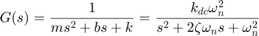

The parameters , , and characterize the behavior of a canonical second-order system.

DC Gain

The DC gain, , again is the ratio of the magnitude of the steady-state step response to the magnitude of the step input, and for stable systems it is the value of the transfer function when . For the forms given,
(6)

Damping Ratio

The damping ratio is a dimensionless quantity charaterizing the rate at which an oscillation in the system's response decays due to effects such as viscous friction or electrical resistance. From the above definitions,
(7)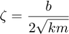

Natural Frequency

The natural frequency is the frequency (in rad/s) that the system will oscillate at when there is no damping, .
(8)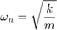

Poles/Zeros

The canonical second-order transfer function has two poles at:
(9)
Underdamped Systems

If , then the system is underdamped. In this case, both poles are complex-valued with negative real parts; therefore, the system is stable but oscillates while approaching the steady-state value. Specifically, the natural response oscillates with the damped natural frequency, (in rad/sec).
k_dc = 1;
w_n = 10;
zeta = 0.2;

s = tf('s');
G1 = k_dc*w_n^2/(s^2 + 2*zeta*w_n*s + w_n^2);

pzmap(G1)
axis([-3 1 -15 15])
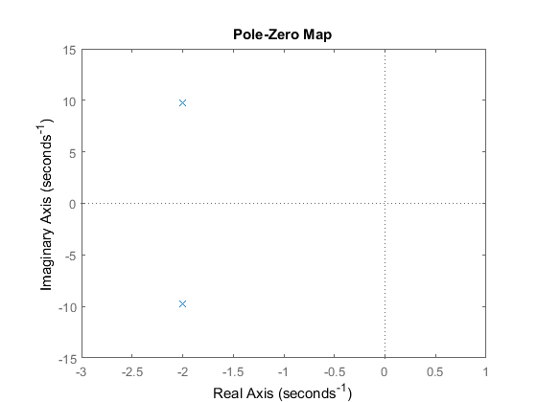
step(G1)
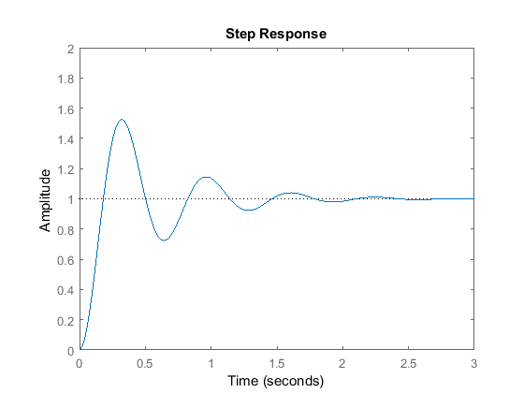
axis([0 3 0 2])
Settling Time

The settling time, , is the time required for the system ouput to fall within a certain percentage of the steady-state value for a step input. For a canonical second-order, underdamped system, the settling time can be approximated by the following equation:
(10)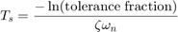

The settling times for the most common tolerances are presented in the following table:
10% | 5% | 2% | 1%
Ts=2.3/(zeta*w_n) | Ts=3/(zeta*w_n) | Ts=3.9/(zeta*w_n) | Ts=4.6/(zeta*w_n)

Percent Overshoot

The percent overshoot is the percent by which a system's step response exceeds its final steady-state value. For a second-order underdamped system, the percent overshoot is directly related to the damping ratio by the following equation. Here, is a decimal number where 1 corresponds to 100% overshoot.
(11)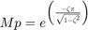

For second-order underdamped systems, the 1% settling time, , 10-90% rise time, , and percent overshoot, , are related to the damping ratio and natural frequency as shown below.
(12)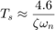
(13)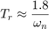
(14)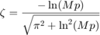

Overdamped Systems

If , then the system is overdamped. Both poles are real and negative; therefore, the system is stable and does not oscillate. The step response and a pole-zero map of an overdamped system are calculated below:

zeta = 1.2;
G2 = k_dc*w_n^2/(s^2 + 2*zeta*w_n*s + w_n^2);

pzmap(G2)
axis([-20 1 -1 1])
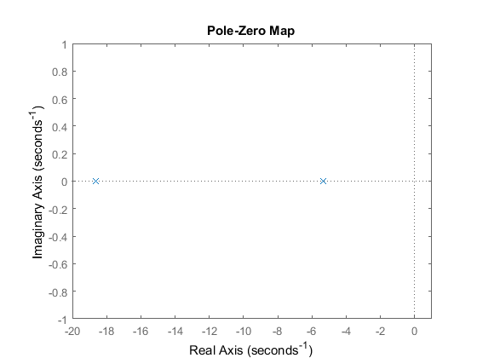
step(G2)
axis([0 1.5 0 1.5])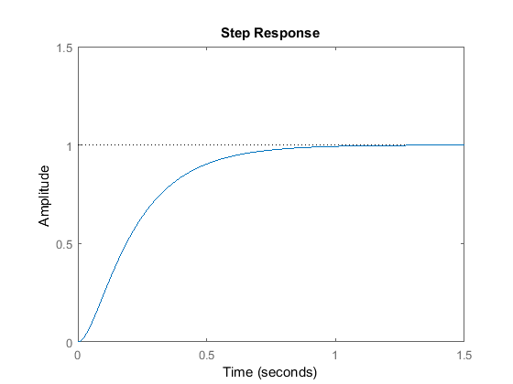
Critically-Damped Systems

If , then the system is critically damped. Both poles are real and have the same magnitude, . For a canonical second-order system, the quickest settling time is achieved when the system is critically damped. Now change the value of the damping ratio to 1, and re-plot the step response and pole-zero map.
zeta = 1;
G3 = k_dc*w_n^2/(s^2 + 2*zeta*w_n*s + w_n^2);
pzmap(G3)
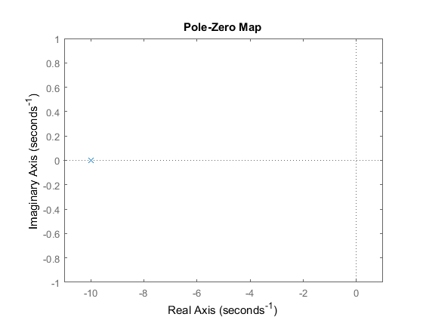
axis([-11 1 -1 1])
step(G3)
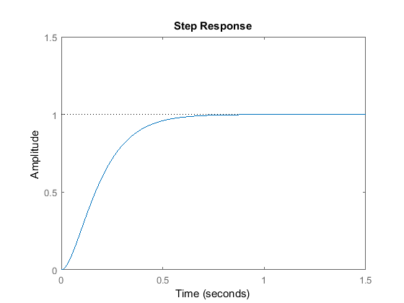
axis([0 1.5 0 1.5])
Undamped Systems

If , then the system is undamped. In this case, the poles are purely imaginary; therefore, the system is marginally stable and the step response oscillates indefinitely.
zeta = 0;
G4 = k_dc*w_n^2/(s^2 + 2*zeta*w_n*s + w_n^2);
pzmap(G4)
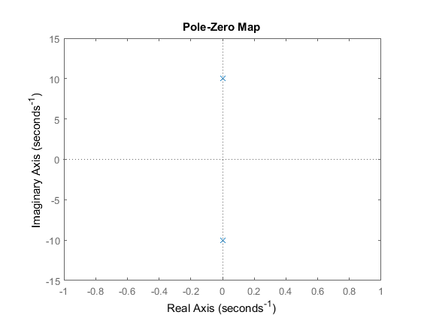
axis([-1 1 -15 15])
step(G4)
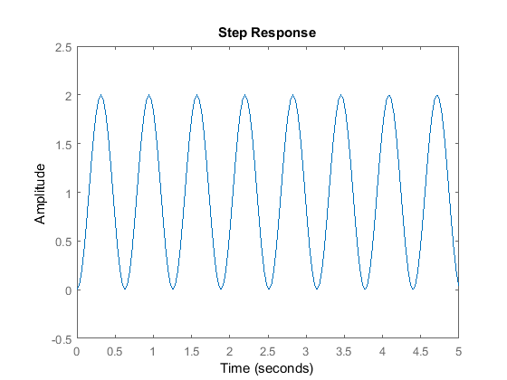
axis([0 5 -0.5 2.5])
Bode Plot

We show the Bode magnitude and phase plots for all damping conditions of a second-order system below:
bode(G1,G2,G3,G4)
legend('underdamped: zeta < 1','overdamped: zeta > 1','critically-damped: zeta = 1',’undamped: zeta=0)
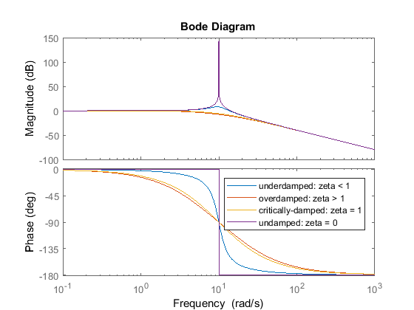
The magnitude of the bode plot of a second-order system drops off at -40 dB per decade in the limit, while the relative phase changes from 0 to -180 degrees. For underdamped systems, we also see a resonant peak near the natural frequency, = 10 rad/s. The size and sharpness of the peak depends on the damping in the system, and is charaterised by the quality factor, or Q-Factor, defined below. The Q-factor is an important property in signal processing.

(15)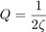

Simulink Basics
Simulink is a graphical extension to MATLAB for modeling and simulation of systems. One of the main advantages of Simulink is the ability to model a nonlinear system, which a transfer function is unable to do. Another advantage of Simulink is the ability to take on initial conditions. When a transfer function is built, the initial conditions are assumed to be zero.
In Simulink, systems are drawn on screen as block diagrams. Many elements of block diagrams are available, such as transfer functions, summing junctions, etc., as well as virtual input and output devices such as function generators and oscilloscopes. Simulink is integrated with MATLAB and data can be easily transferred between the programs.

Starting Simulink
Simulink is started from the MATLAB command prompt by entering the following command:
simulink

Alternatively, you can hit the Simulink button at the top of the MATLAB window as shown here:

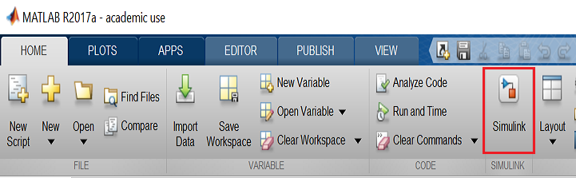

When it starts, Simulink brings up a single window, entitled Simulink Start Page which can be seen over page.
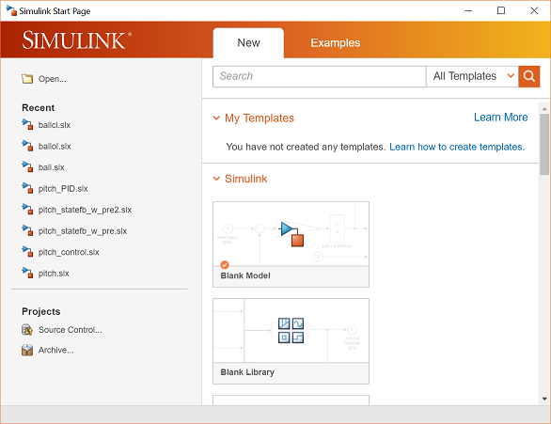
Once you click on Blank Model, a new window will appear as shown below.
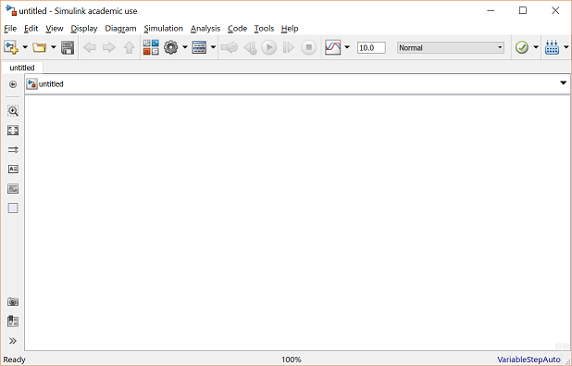

Model Files
In Simulink, a model is a collection of blocks which, in general, represents a system. In addition to creating a model from scratch, previously saved model files can be loaded either from the File menu or from the MATLAB command prompt. Open a file in Simulink by entering the following command in the MATLAB command window. (Alternatively, you can load this file using the Open option in the File menu in Simulink, or by hitting Ctrl-O in Simulink).

A new model can be created by selecting New from the File menu in any Simulink window (or by hitting Ctrl-N).
The model window should look like this:
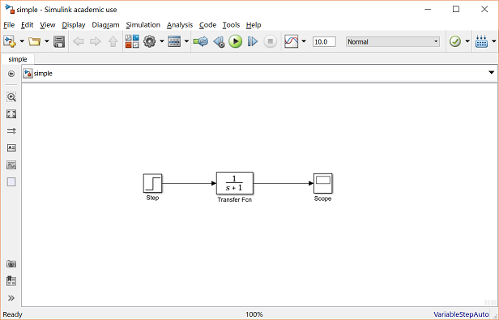

Basic Elements
There are two major classes of items in Simulink: blocks and lines. Blocks are used to generate, modify, combine, output, and display signals. Lines are used to transfer signals from one block to another.

Blocks
There are several general classes of blocks within the Simulink library:
- Sources: used to generate various signals
- Sinks: used to output or display signals
- Continuous: continuous-time system elements (transfer functions, state-space models, PID controllers, etc.)
- Discrete: linear, discrete-time system elements (discrete transfer functions, discrete state-space models, etc.)
- Math Operations: contains many common math operations (gain, sum, product, absolute value, etc.)
- Ports & Subsystems: contains useful blocks to build a system
Blocks have zero to several input terminals and zero to several output terminals. Unused input terminals are indicated by a small open triangle. Unused output terminals are indicated by a small triangular point.

The block shown below has an unused input terminal on the left and an unused output terminal on the right.
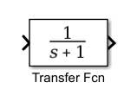
Lines
Lines transmit signals in the direction indicated by the arrow. Lines must always transmit signals from the output terminal of one block to the input terminal of another block. On exception to this is a line can tap off of another line, splitting the signal to each of two destination blocks, as shown below:

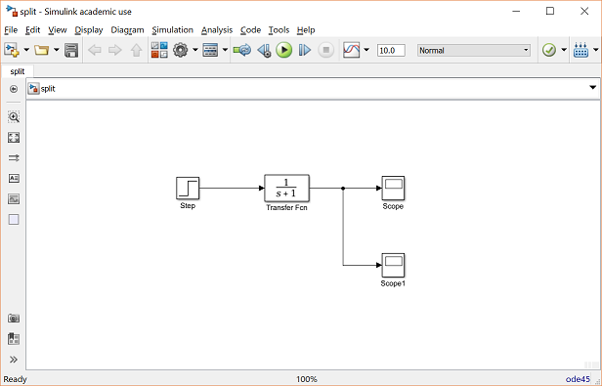
Lines can never inject a signal into another line; lines must be combined through the use of a block such as a summing junction.

A signal can be either a scalar signal or a vector signal. For Single-Input, Single-Output (SISO) systems, scalar signals are generally used. For Multi-Input, Multi-Output (MIMO) systems, vector signals are often used, consisting of two or more scalar signals. The lines used to transmit scalar and vector signals are identical. The type of signal carried by a line is determined by the blocks on either end of the line.

Simple Example

See if you can create this simple model that consists of three blocks: Step, Transfer Function, and Scope.

The Step is a Source block from which a step input signal originates.

This signal is transferred through the line in the direction indicated by the arrow to the Transfer Function Continuous block.

The Transfer Function block modifies its input signal and outputs a new signal on a line to the Scope.

The Scope is a Sink block used to display a signal much like an oscilloscope.

There are many more types of blocks available in Simulink, some of which will be used later. Right now, we will examine just the three we have used in this simple model.

Modifying Blocks
A block can be modified by double-clicking on it. For example, if you double-click on the Transfer Function block in the Simple model, you will see the following dialog box.

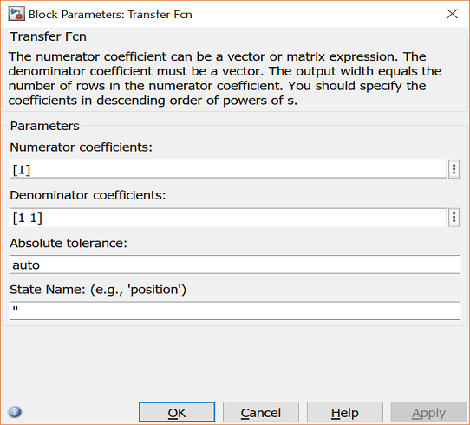
This dialog box contains fields for the numerator and the denominator of the block's transfer function. By entering a vector containing the coefficients of the desired numerator or denominator polynomial, the desired transfer function can be entered. For example, to change the denominator to
(1)

enter the following into the denominator field
[1 2 4]
and hit the close button, the model window will change to the following,
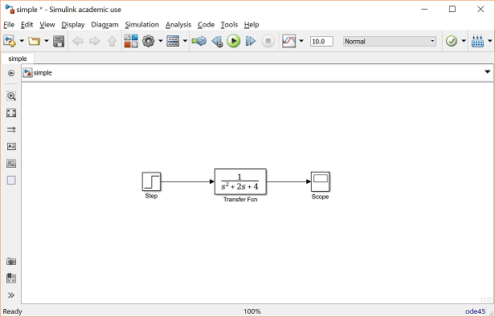
which reflects the change in the denominator of the transfer function.
The Step block can also be double-clicked, bringing up the following dialog box
.
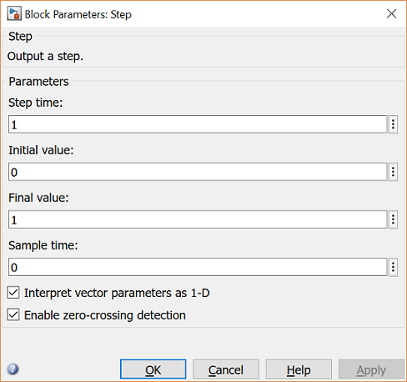
The default parameters in this dialog box generate a step function occurring at time = 1 sec, from an initial level of zero to a level of 1 (in other words, a unit step at t = 1). Each of these parameters can be changed. Close this dialog before continuing.
The most complicated of these three blocks in the Scope block. Double-clicking on this brings up a blank oscilloscope screen.

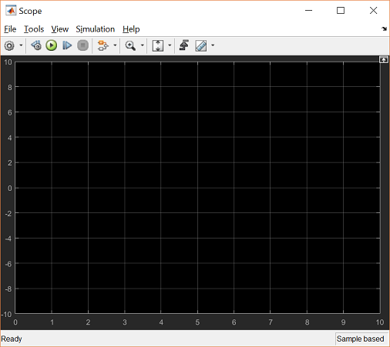
When a simulation is performed, the signal which feeds into the scope will be displayed in this window. Detailed operation of the scope is not covered in this tutorial.

Running Simulations
To run a simulation, we will work with your current model file:

You should currentlyhave following model window.
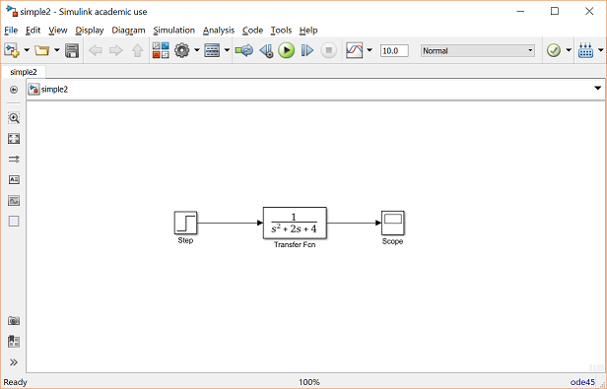
Before running a simulation of this system, first open the scope window by double-clicking on the scope block. Then, to start the simulation, either select Run from the Simulation menu, click the Play button at the top of the screen, or hit Ctrl-T.

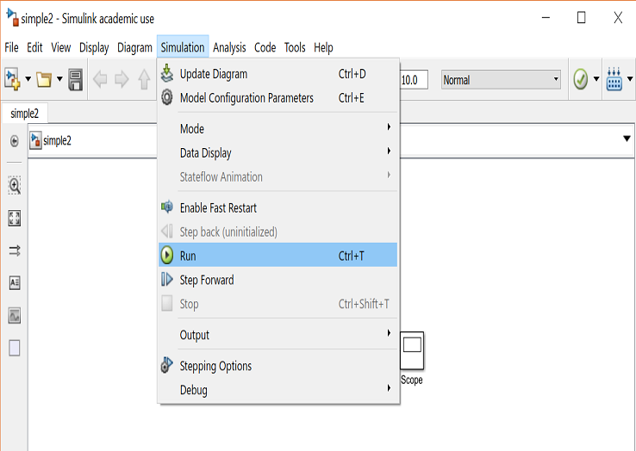

The simulation should run very quickly and the scope window will appear as shown below.
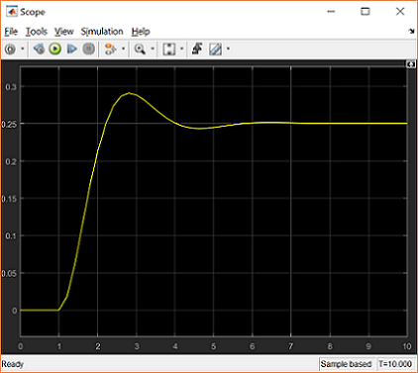
Note that the step response does not begin until t = 1. This can be changed by double-clicking on the step block. Now, we will change the parameters of the system and simulate the system again. Double-click on the Transfer Function block in the model window and change the denominator to:
[1 20 400]

Re-run the simulation (hit Ctrl-T) and you should see the following in the scope window.
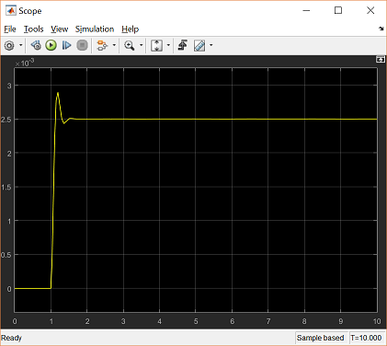
Since the new transfer function has a very fast response, it compressed into a very narrow part of the scope window. This is not really a problem with the scope, but with the simulation itself. Simulink simulated the system for a full ten seconds even though the system had reached steady state shortly after one second.
To correct this, you need to change the parameters of the simulation itself. In the model window, select Model Configuration Parameters from the Simulation menu. You will see the following dialog box.

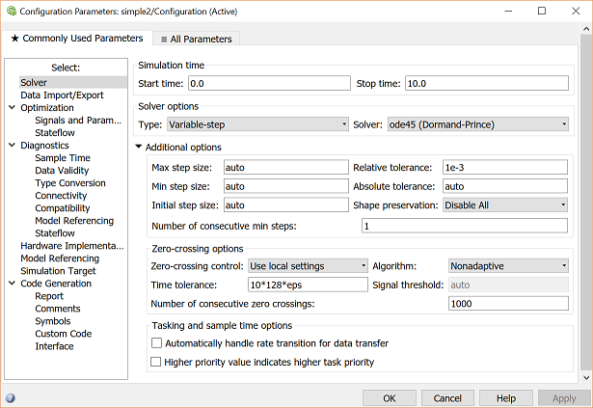
There are many simulation parameter options; we will only be concerned with the start and stop times, which tell Simulink over what time period to perform the simulation. Change Start time from 0.0 to 0.8 (since the step doesn't occur until t = 1.0). Change Stop time from 10.0 to 2.0, which should be only shortly after the system settles. Close the dialog box and rerun the simulation. Now, the scope window should provide a much better display of the step response as shown below.

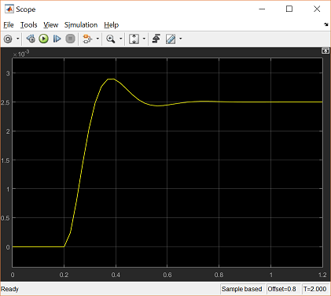

Building Systems
In this section, you will learn how to build systems in Simulink using the building blocks in Simulink's Block Libraries. You will build the following system.

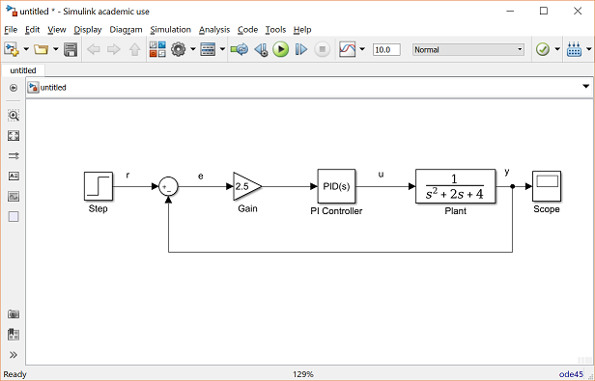
First, you will gather all of the necessary blocks from the block libraries. Then you will modify the blocks so they correspond to the blocks in the desired model. Finally, you will connect the blocks with lines to form the complete system. After this, you will simulate the complete system to verify that it works.

Gathering Blocks
Follow the steps below to collect the necessary blocks:
- Create a new model (New from the File menu or hit Ctrl-N). You will get a blank model window.
- Click on the Tools tab and then select Library Browser.
- Then click on the Sources listing in the Simulink library browser.

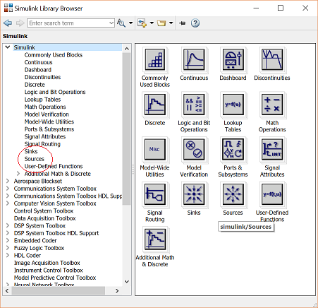
- This will bring up the Sources block library. Sources are used to generate signals.

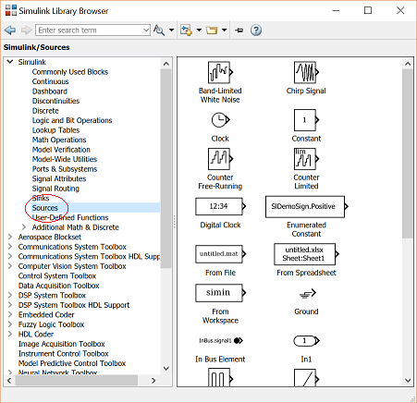
- Drag the Step block from the Sources window into the left side of your model window.

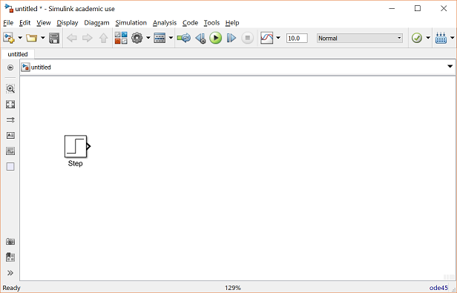
- Click on the Math Operations listing in the main Simulink window.
- From this library, drag a Sum and Gain block into the model window and place them to the right of the Step block in that order.
- Click on the Continuous listing in the main Simulink window.
- First, from this library, drag a PID Controller block into the model window and place it to the right of the Gain block.
- From the same library, drag a Transfer Function block into the model window and place it to the right of the PID Controller block.

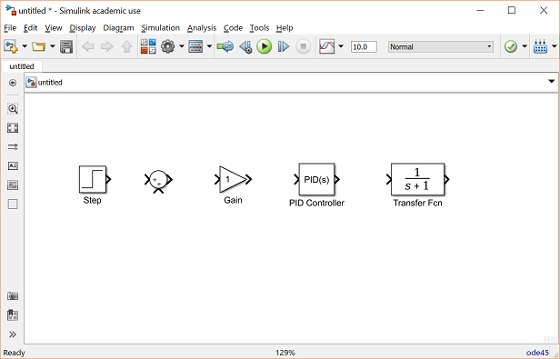
- Click on the Sinks listing in the main Simulink window.
- Drag the Scope block into the right side of the model window.

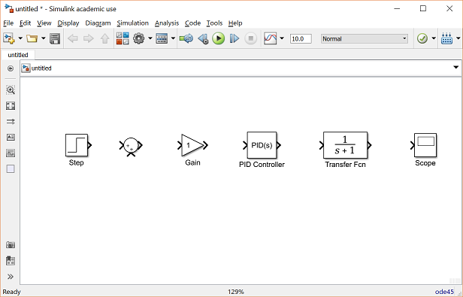
Modify Blocks
Follow these steps to properly modify the blocks in your model.
- Double-click on the Sum block. Since you will want the second input to be subtracted, enter +- into the list of signs field. Close the dialog box.
- Double-click the Gain block. Change the gain to 2.5 and close the dialog box.
- Double-click the PID Controller block and change the Proportional gain to 1 and the Integral gain to 2. Close the dialog box.
- Double-click the Transfer Function block. Leave the numerator [1], but change the denominator to [1 2 4]. Close the dialog box. The model should appear as:

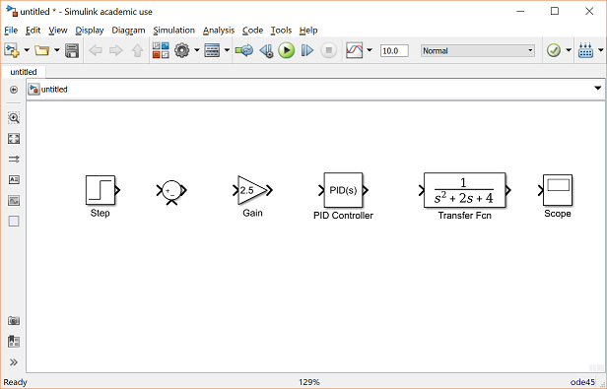
- Change the name of the PID Controller block to PI Controller by double-clicking on the word PID Controller.

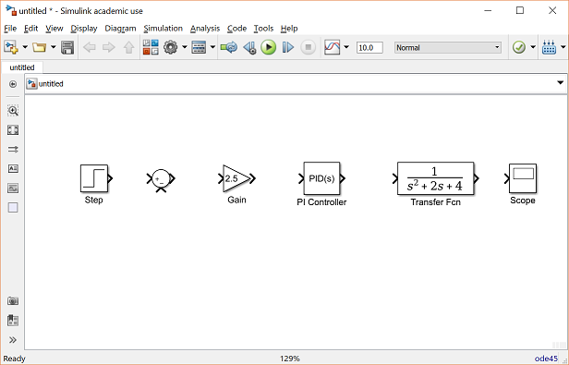
- Similarly, change the name of the Transfer Function block to Plant. Now, all the blocks are entered properly. Your model should appear as:

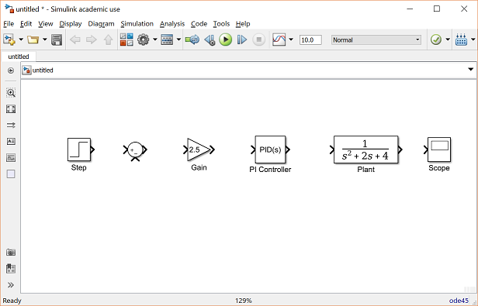

Connecting Blocks with Lines
Now that the blocks are properly laid out, you will now connect them together. Follow these steps.
- Drag the mouse from the output terminal of the Step block to the positive input of the Sum input. Another option is to click on the Step block and then Ctrl-Click on the Sumblock to connect the two togther. You should see the following.

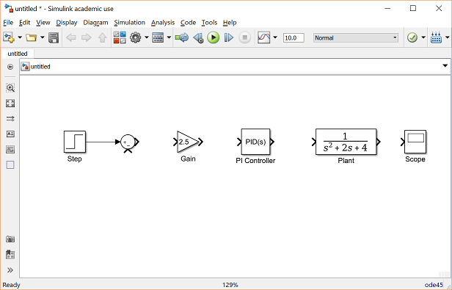
- The resulting line should have a filled arrowhead. If the arrowhead is open and red, as shown below, it means it is not connected to anything.

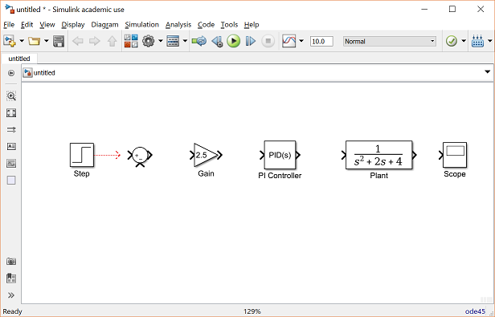
- You can continue the partial line you just drew by treating the open arrowhead as an output terminal and drawing just as before. Alternatively, if you want to redraw the line, or if the line connected to the wrong terminal, you should delete the line and redraw it. To delete a line (or any other object), simply click on it to select it, and hit the delete key.
- Draw a line connecting the Sum block output to the Gain input. Also draw a line from the Gain to the PI Controller, a line from the PI Controller to the Plant, and a line from the Plant to the Scope. You should now have the following.

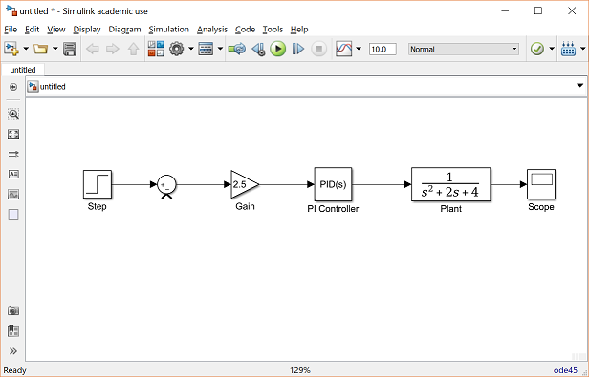
- The line remaining to be drawn is the feedback signal connecting the output of the Plant to the negative input of the Sum block. This line is different in two ways. First, since this line loops around and does not simply follow the shortest (right-angled) route so it needs to be drawn in several stages. Second, there is no output terminal to start from, so the line has to tap off of an existing line.
- Drag a line off the negative portion of the Sum block straight down and release the mouse so the line is incomplete. From the endpoint of this line, click and drag to the line between the Plant and the Scope. The model should now appear as follows.
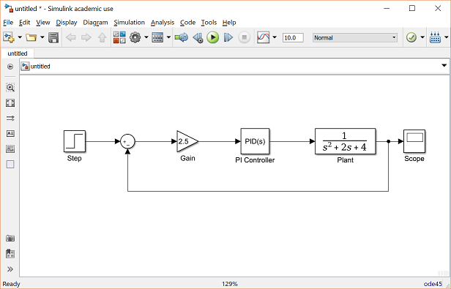
- Finally, labels will be placed in the model to identify the signals. To place a label anywhere in the model, double-click at the point you want the label to be. Start by double-clicking above the line leading from the Step block. You will get a blank text box with an editing cursor as shown below.

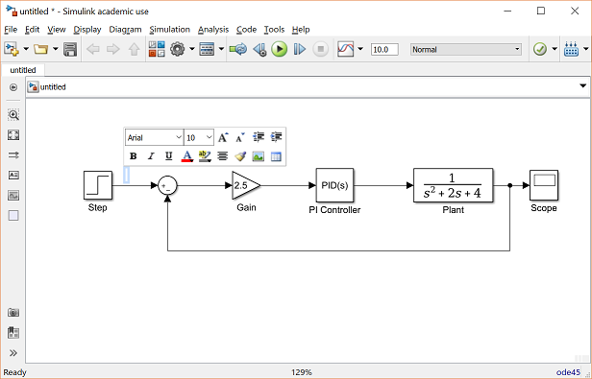
- Type an r in this box, labeling the reference signal and click outside it to end editing.
- Label the error (e) signal, the control (u) signal, and the output (y) signal in the same manner. Your final model should appear as:

To save your model, select Save As in the File menu and type in any desired model name. The completed model can be downloaded by right-clicking here and then selecting Save link as ....

Simulation

Now that the model is complete, you can simulate the model. Select Run from the Simulation menu to run the simulation. Double-click on the _Scope_block to view its output and you should see the following:

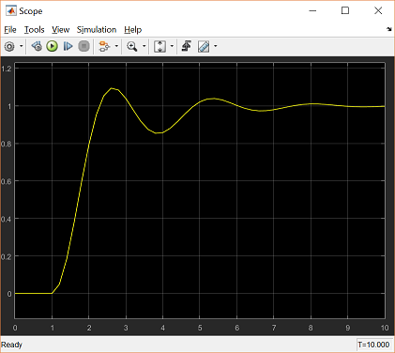
Taking Variables from MATLAB
In some cases, parameters, such as gain, may be calculated in MATLAB to be used in a Simulink model. If this is the case, it is not necessary to enter the result of the MATLAB calculation directly into Simulink. For example, suppose we calculated the gain in MATLAB in the variable K. Emulate this by entering the following command at the MATLAB command prompt.
K = 2.5

This variable can now be used in the Simulink Gain block. In your Simulink model, double-click on the Gain block and enter the following the Gain field.
K
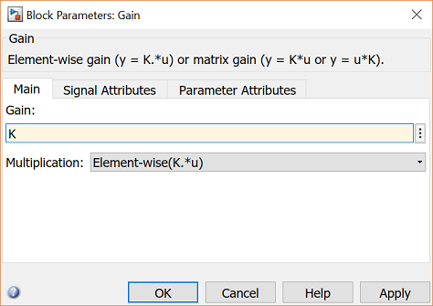
Close this dialog box. Notice now that the Gain block in the Simulink model shows the variable K rather than a number.

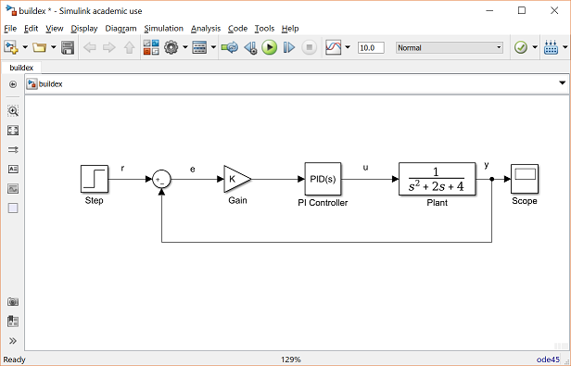
Now, you can re-run the simulation and view the output on the Scope. The result should be the same as before.
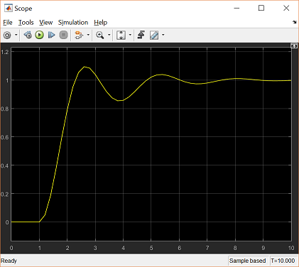
Now, if any calculations are done in MATLAB to change any of the variables used in the Simulink model, the simulation will use the new values the next time it is run. To try this, in MATLAB, change the gain, K, by entering the following at the command prompt.
K = 5
Start the Simulink simulation again and open the Scope window. You will see the following output which reflects the new, higher gain.
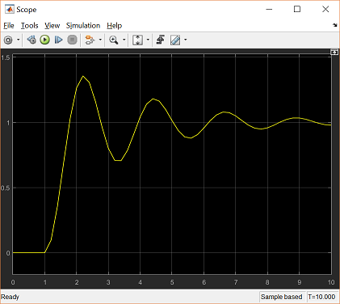
Besides variables and signals, even entire systems can be exchanged between MATLAB and Simulink.

